Surgical Operations Quality Improvement

Group Members:

1). Joann Vuong [joann.vuong@utah.eduu0760934](mailto:joann.vuong@utah.eduu0760934)

2). Jeff Thornhill [jeffrey.thornhill@utah.eduu1328998](mailto:jeffrey.thornhill@utah.eduu1328998)

3). Theresa Aguilar [theresa.aguilar@utah.eduu1329017](mailto:theresa.aguilar@utah.eduu1329017)

GitHub Repository:

1). <https://github.com/tere646/Surgical-Data-Wrangling>

1. The wrangling problem:

Can a hospital use Medicare claim type files to participate in the ACS NSQIP program?

1. Data quality assessment (descriptive statistics) of the dataset(s): Our data came in the form of Medicare Claims Synthetic Public use files, so the data was very uniform and didn’t contain pertinent missing values. We started with 4,008,836 inpatient claims with 83 data points per claim.
2. Steps taken to wrangle (and integrate) the data
   1. Acquiring data
      1. CMS.gov website
      2. Selecting six measures
      3. Retrieving ICD9 Codes for diagnosis and procedures
   2. Cleaning noise and null columns
   3. Standardizing and formatting data (ie.. Date columns)
   4. Filtering data through determined parameters (diagnosis and procedure codes)
   5. Consolidating data into a coherent whole
      1. Joining, concatenating, and merging files
   6. Removing duplicates
   7. Analyze data
3. Repeat data quality assessment of the wrangled data

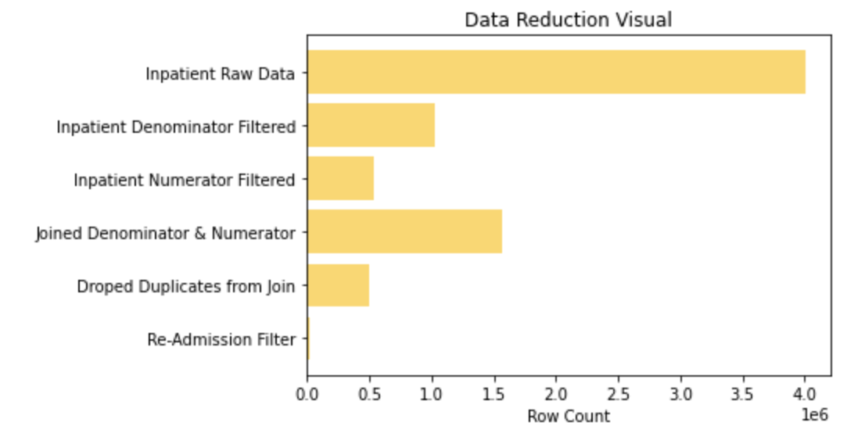

1. Any evidence to show that the wrangled data is usable:

|  |  |  |  |
| --- | --- | --- | --- |
| **Measure** | **Numerator** | **Denominator** | **Rate** |
| Pneumonia | 3678 | 23557 | 15.6% |
| Sepsis | 908 | 23557 | 3.8% |
| Colon | 524 | 23557 | 2.2% |
| UTI | 164 | 23557 | 0.69% |
| Deep Vein | 8 | 23557 | 0.03% |
| Death | 0 | 23557 | 0% |

1. Lessons learned: Start off with a solid understanding of what you are trying to accomplish. Know what you are starting out with and what you want to end up with. Based on the preliminary evaluation of the data you are starting with, develop an action plan. Be prepared to modify your plan as you will undoubtably encounter unforeseen issues. Communicate with your team because every though process is different and the best solutions come from discussion.
2. References:

Delisle, Sylvain & Kim, Bernard & Deepak, Janaki & Siddiqui, Tariq & Gundlapalli, Adi & Samore, Matthew & D'Avolio, Leonard. (2013). Using the Electronic Medical Record to Identify Community-Acquired Pneumonia: Toward a Replicable Automated Strategy. PloS one. 8. e70944. 10.1371/journal.pone.0070944.

Makam AN, Nguyen OK, Clark C, et al. Predicting 30-Day Pneumonia Readmissions Using Electronic Health Record Data. *J Hosp Med*. 2017;12(4):209-216. doi:10.12788/jhm.2711

<https://www.icd10data.com/ICD10CM/Codes/N00-N99/N30-N39/N39-/N39.0>

<https://labtestsonline.org/conditions/urinary-tract-infection>

<https://labtestsonline.org/conditions/pneumonia>

<https://www.curemd.com/tutorials/codes-pdf/urology.pdf>

<https://www.hopkinsmedicine.org/health/treatment-tests-and-therapies/common-surgical-procedures>

<https://pandas.pydata.org/pandas-docs/stable/user_guide/timeseries.html#periodindex-and-period-range>

<https://stackoverflow.com/questions/46046136/find-out-if-a-date-is-more-than-30-days-old>

<https://pandas.pydata.org/pandas-docs/stable/reference/api/pandas.concat.html>

<https://stackoverflow.com/questions/40885318/create-a-new-dataframe-from-selecting-specific-rows-from-existing-dataframe-pyth>

<https://www.kite.com/python/answers/how-to-select-unique-pandas-dataframe-rows-in-python>

<https://cmdlinetips.com/2018/03/how-to-filter-a-pandas-dataframe-based-on-null-values-of-a-column/>

<https://stackoverflow.com/questions/29971075/count-number-of-non-nan-entries-in-every-column-of-dataframe>

<https://www.facs.org/Quality-Programs/ACS-NSQIP>

<http://www.consort-statement.org/consort-statement/flow-diagram>

<https://www.cms.gov/research-statistics-data-and-systems/downloadable-public-use-files/synpufs>

<https://www.nm.org/about-us/quality/quality-measures/sites-of-care/northwestern-memorial-hospital/surgery/post-op-complications>

<https://www.hcup-us.ahrq.gov/toolssoftware/surgeryflags_svcproc/surgeryflags.jsp>